The Gruffalo Reading
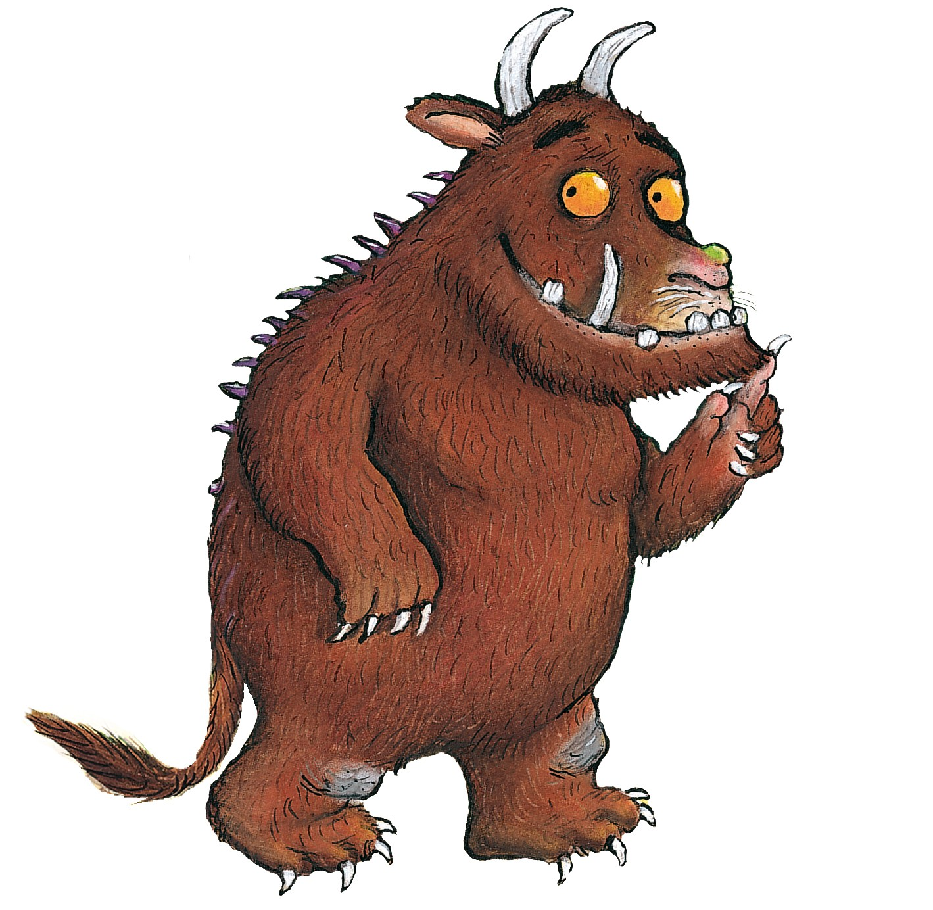
Comprehension.

Tick the right box:
Who took a stroll in the wood? | A Fox  A mouse
What colour was the mouse? | Brown  White  Black
Did the mouse say the Gruffalo had terrible tusks, claws and teeth? | Yes  No
How was the wood described...? | Deep & dark  Big & bright  Cold & old
Did the animals think the mouse looked... | bad  good
What colour were the Gruffalo’s prickles? | Pink  Brown  purple
Did the Gruffalo really exist? | Yes  No
Did the mouse tell the animals that the Gruffalo had two warts at the end of his nose? | Yes  No

Helpful hints:
&
Means and
Self Assessment

ANSWERS:
- A mouse
- Brown
- Yes
- Deep & dark
- Good
- purple
- yes
- No (one wart)

